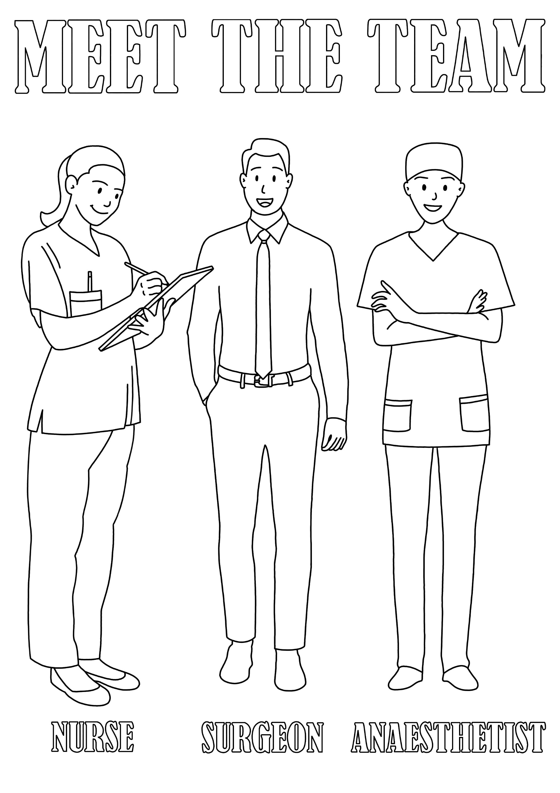

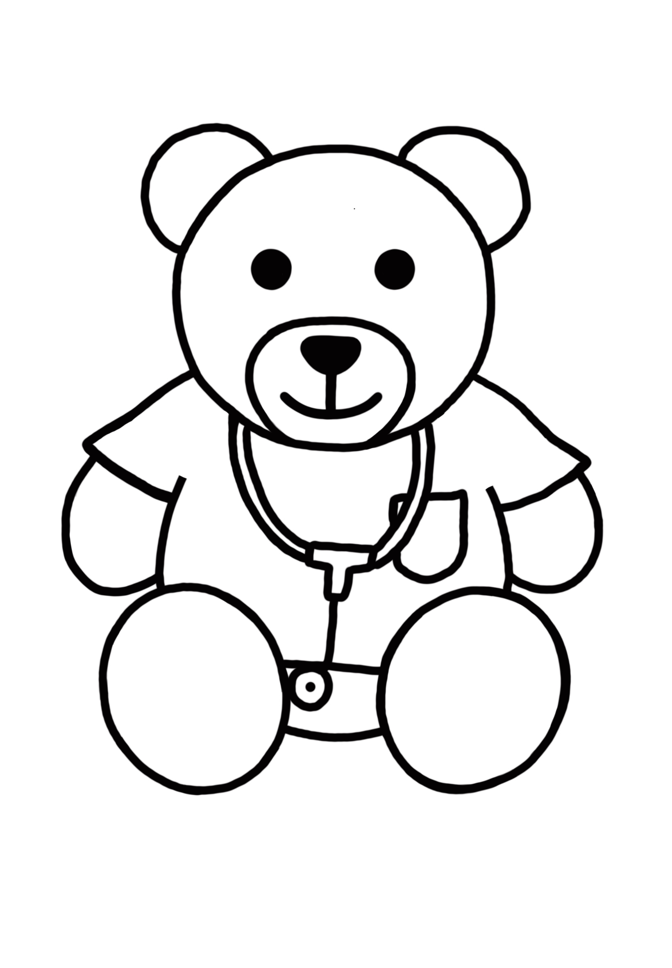

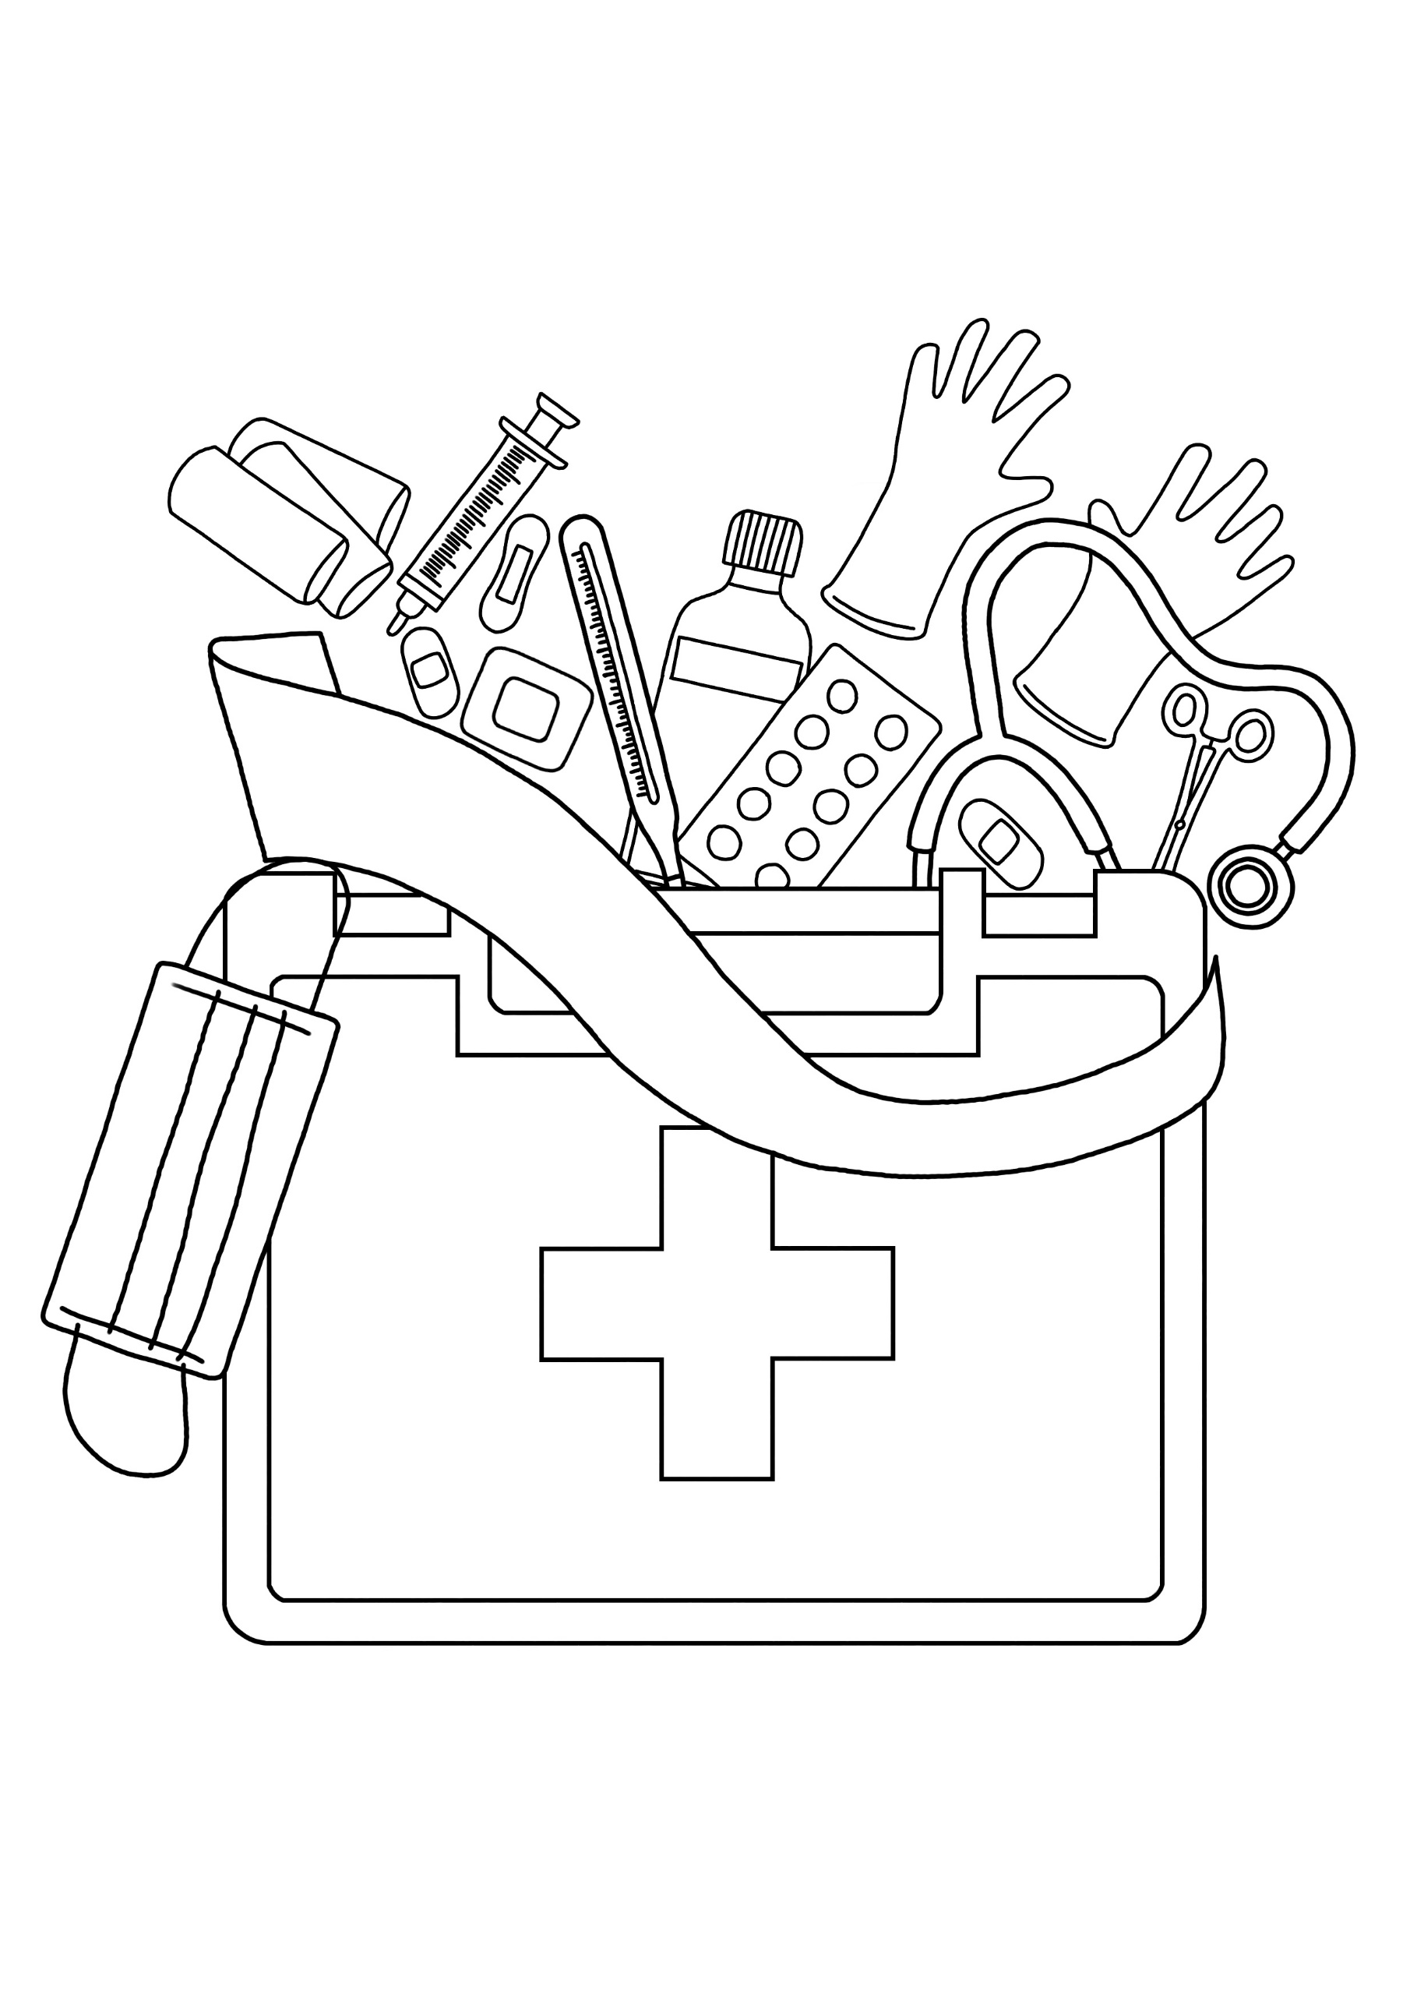

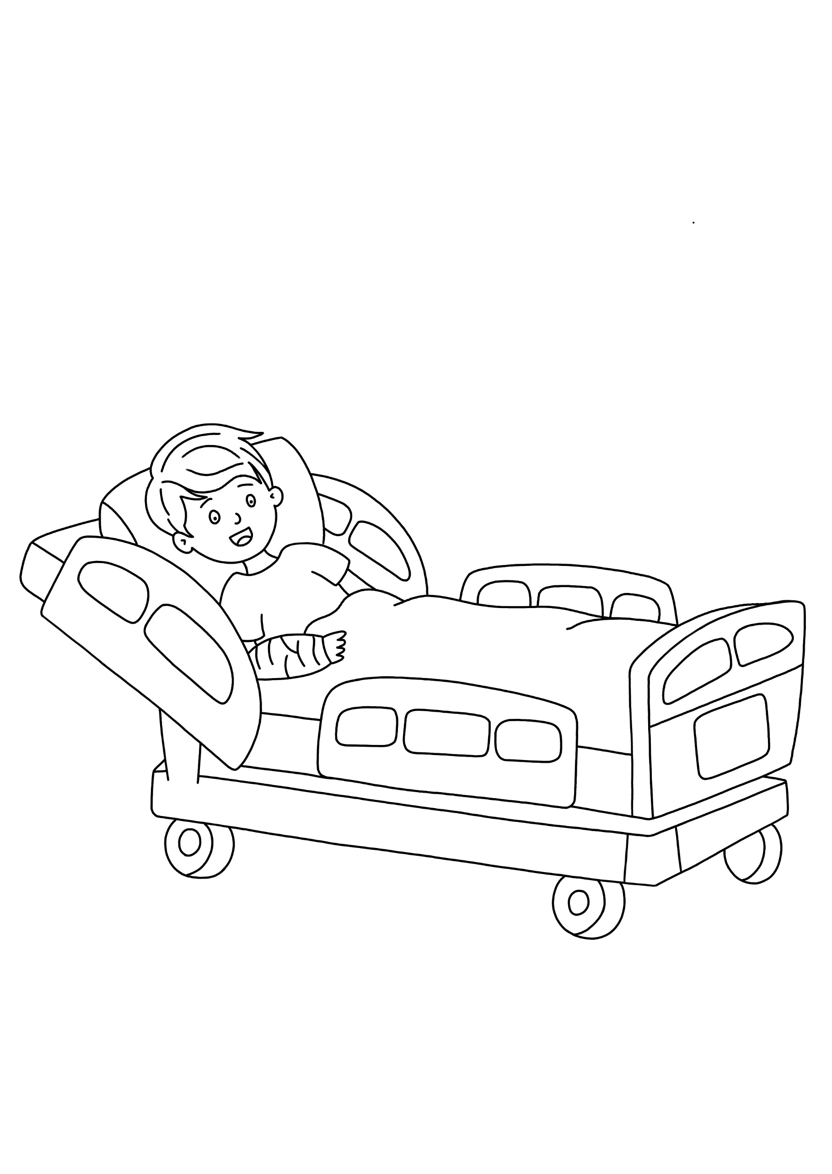

Equipment library

To collect bladder scanner and fix the defibrillator not printing – medical equipment library

e