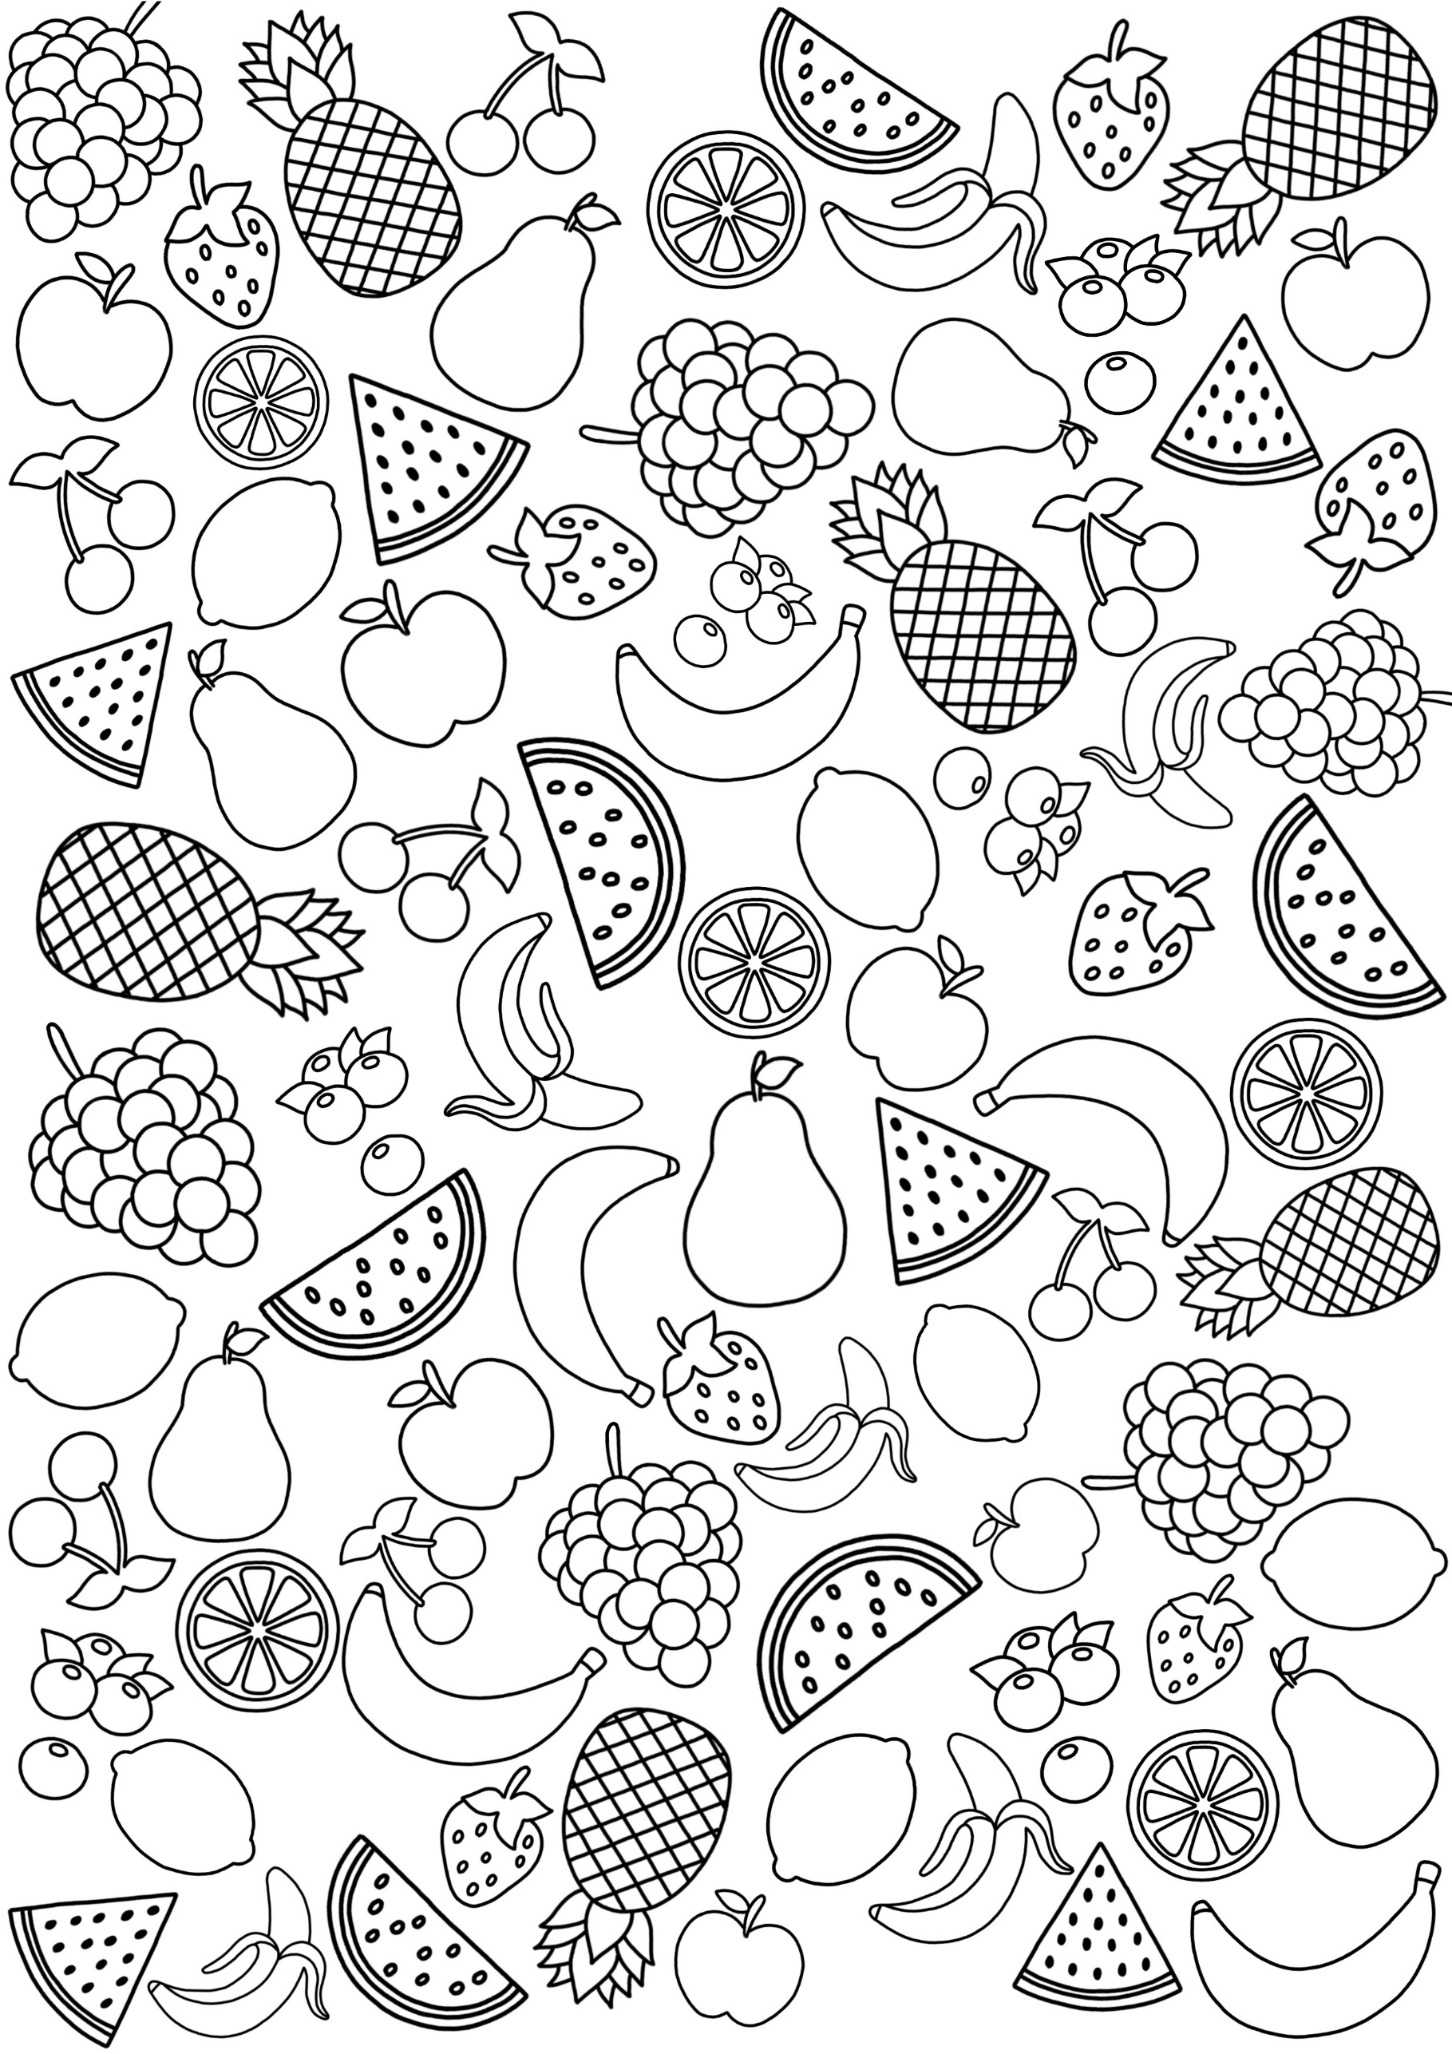

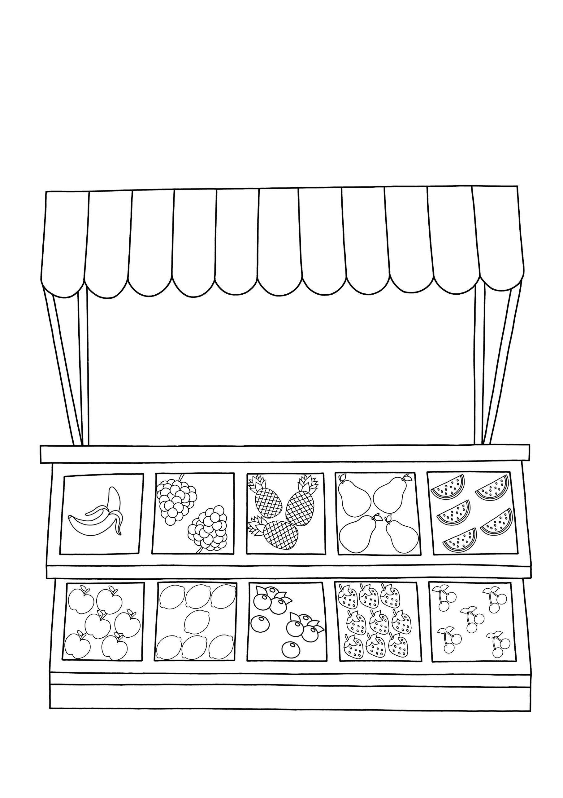

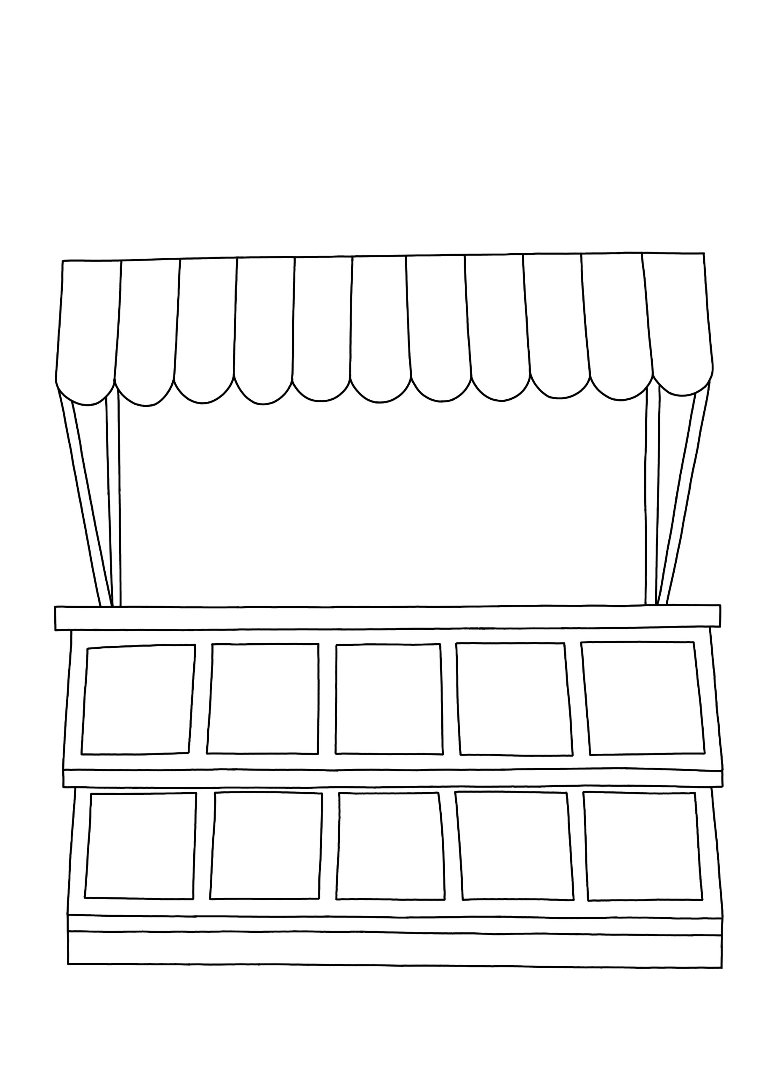

CAN YOU HELP THE FARMER FILL HIS STALL WITH FRUIT AND VEGETABLES?